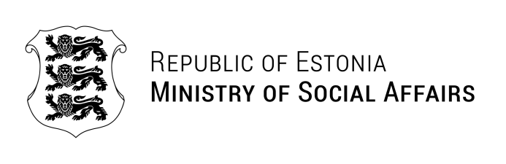
Ms Ana Dujić  Head of Policy Lab Digital, Work and Society  Federal Ministry of Labour and Social Affairs of Germany  ana.dujic@bmas.bund.de | Our ref. 25.08.2025 No 1.4-2/2165-1
Invitation letter

Dear Ms Ana Dujić,

I would like to extend my thanks to you and your team for your interest in visiting Estonia and learning more about the Estonian experience of using digital solutions in the field of social protection.

It would be a pleasure to welcome you at the Ministry of Social Affairs of Estonia as part of your visit. I would propose planning the visit for the second half of October, as suggested by the organizing teams of both countries.

Kindly inform us of the specific dates most suitable for you, upon your availability. Our partners will coordinate the necessary meetings to ensure that you will gain the most out of your visit.

I look forward to exchanges with you, and hope that your visit to Tallinn will offer new ideas and meaningful insights.

Yours sincerely,

Jaanika Merilo
Head of Digital Health and Care
Ministry of Social Affairs of Estonia

Copy to: Berufsgenossenschaft der Bauwirtschaft,
Mr Jakob Kort, jakob.kort@bgbau.de

Tiina Rootamm +372 5367 5311, tiina.rootamm@sm.ee

